3GPP TSG RAN WG1 #125 R1- 2603868
Dalian, China, May. 18th ~ 22nd, 2026

Agenda Item: 10.8.2
Source: Apple
Title: On Aspects of Integration of ISAC with Communications
Document for: Discussion

1 Introduction
In RAN #108, a new SID captured the objectives of a Study on Integrated Sensing and Communication (ISAC) for 6GR as follows [1]:

  - Sensing – Studies to be based on use cases and associated requirements, as defined in [2, TR38.914]
    - PHY functions and procedures for sensing technology (e.g., waveform. reference signals, measurement feedback, etc…) [RAN1, RAN4]
    - Evaluate sensing performance and if necessary, extend channel modelling, for the selected use cases [RAN1]
    - Aspects of integration with communication services [RAN1]
    - higher layer procedures and protocol aspects [RAN2]
    - RAN4 aspects of sensing including RF, coexistence, and testability in coordination with other WGs [RAN4]
    - Note: RAN1 identify detailed requirements, if triggered by TSG RAN
NOTE: Coordination with TSG-SA and SA WGs will be done, as necessary

In this contribution we discuss aspects of integration with communication services including PHY functions and procedures such as reference signals and measurement reports for ISAC in 6GR.

2 Sensing Modes and Use Cases
In the R20 5G-A ISAC study, gNB-based mono-static sensing (i.e., single TRP with co-located sensing transmitter and receiver) in a UMA-AV scenario for the UAV use case was analysed [3]. For ISAC in the 6G first release, use cases that involve the UE as a sensing transmitter and/or receiver should be supported. These include use cases on object detection and tracking of the objects and environment in the area surrounding the UE/TRP and on Sensing-Aided Communications (SAC) for both the network and the UE as captured in R19 SA1 ISAC Use Cases document [4]. Examples including Sensing Assisted Beam Management and Sensing Assisted Configuration Parameter Selection. Privacy for sensing data/entity should be central to the design.

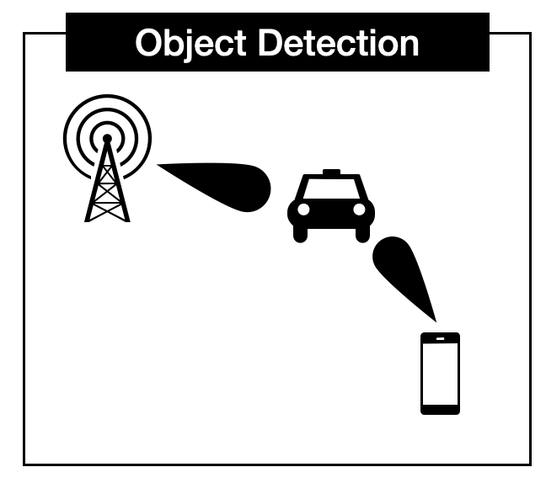 | 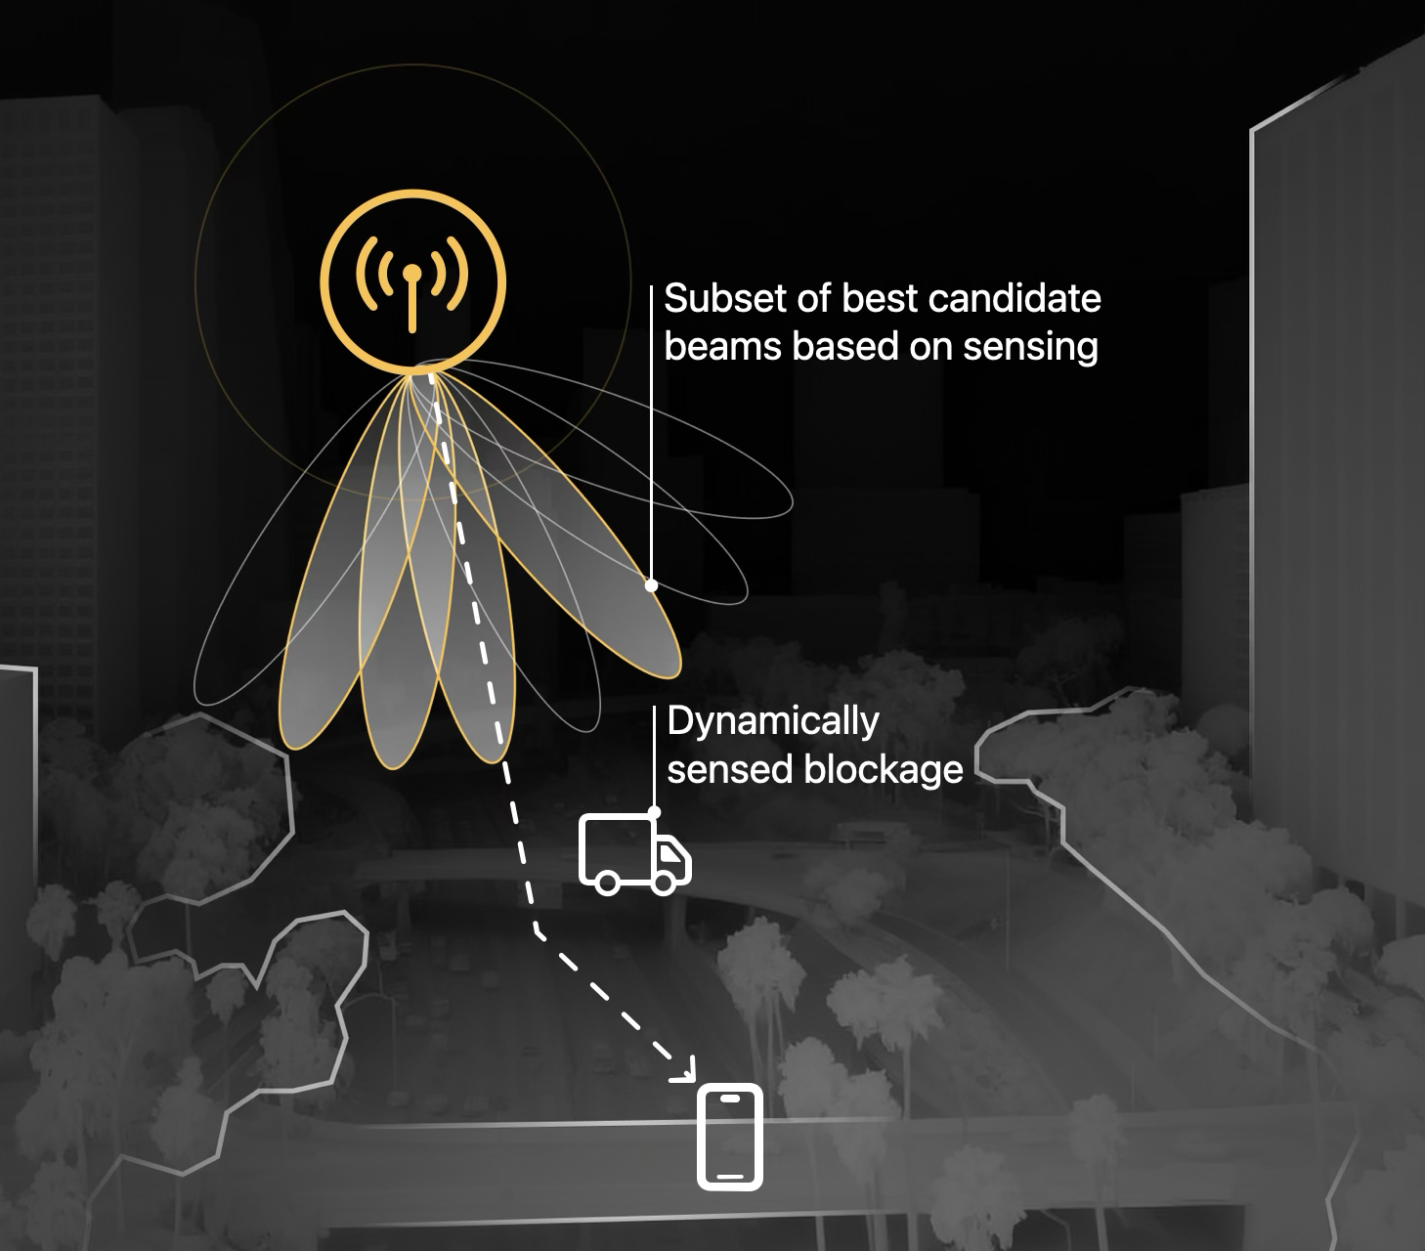
Object detection/tracking in surroundings | Sensing Assisted Beam Management
Figure 1: Example ISAC Use Cases

It is necessary to support a UE-centric mode of operation [5] in which the UE may request, process, and most importantly, consume sensing measurements while the NW is responsible for resource allocation. Allowance for all network nodes as sensing result/service consumers is also essential including the UE-mono-static, TRP-UE bi-static, UE-TRP bi-static, and UE-UE bi-static sensing modes. This implies that the sensing PHY functions and procedures and other aspects of integration with communication services support all the sensing modes including a UE-centric sensing mode and other UE based sensing scenarios be supported. One last important issue is that privacy for sensing entity, sensing data, and associated PHY functions and procedures should be central to the design.

Proposal 1: For ISAC in the 6G first release, use cases that involve the UE as a sensing transmitter and/or receiver should be supported in 6GR

Proposal 2: Allowance for all network nodes as sensing result/service consumers is essential i.e. UE-mono-static, TRP-UE bi-static, UE-TRP bi-static, UE-UE bi-static
- UE-centric modes in which the UE may request, process, and most importantly, consume sensing measurements while the NW is responsible for resource allocation should be supported in 6GR

Proposal 3: PHY functions and procedures and communications integration for key Use Cases such as Object Detection and Tracking of objects and the environment surrounding the UE/TRP and Sensing Aided Communications should be studied.

Proposal 4: Privacy for sensing entity, sensing data, and associated PHY functions and procedures should be central to the design.

3 PHY functions and Procedures
The following areas of study are necessary to support the integration of sensing with communications services:

- Reference Signal Design
- Reference Signal Pattern Design
- ISAC Multiple Access and Interference
- Sensing Measurements and Feedback
- Bandwidth Aggregation
- Power Control
- Beam Management

3.1 Reference Signal Design
In RAN1 #124-bis, the following agreements were made on signal design and RE patterns for RS for ISAC [6]
Agreement:
- On RS for ISAC, study at least the following aspects, considering sensing performance, resource overhead and impact to communication
  - RS for communication is reused for sensing
  - Enhanced RS for sensing, taking reuse of RS for communication as starting point
    - Note: Part of or all of the RS may be used for communication purpose, and it does not mean the final decision on whether the enhanced RS is used for communication purpose is to be made in this agenda.
  - Dedicated RS for sensing

3.1.1 RS for communication is reused for sensing
In 5G there are multiple types of RS with distinct characteristics (BW, periodicity, comb manner, etc.). For 6G ISAC, the existing RS types should be investigated/evaluated and potentially enhanced for sensing purpose. Note that as 6G evolves, the 6GR RSs should also be pulled into the study.

In the following, we list the NR RS types and assess their sensing characteristics and limitations. Table 1 summarizes the key properties of these RSs.

Table 1: NR Reference Signals and Sensing Characteristics
Reference Signal | Property | Sensing Implication — Benefit(B)/Gap(G)
PSS/SSS | 20 RBs BW; always on; known sequence, fixed T-F location | (B) Zero-overhead, always available for coarse sensing; no configuration needed
 | Narrow BW (20 RBs) | (G) Limited range resolution, max range, and velocity ambiguity
PBCH-DMRS | Same BW as SSB; tied to SSB | (G) No independent sensing value beyond SSB
DMRS | Spans full allocated data BW; zero additional overhead | (B) Best efficiency for mono-static/SAC if data grant allocated — range resolution scales with grant
 | Always precoded (UE-specific); only present during PDSCH/PUSCH | (G) Not usable cell-wide; no sensing outside data scheduling
 | May not be contiguous (RBG); up to 4 symbols | (G) Frequency gaps reduce coherent processing; limited Doppler extent
PRS | Not precoded; staggered; configurable comb-2/4/6/12; wide BW; periodic | (B) Best DL sensing: cell-wide, max unambiguous range, flexible density
 | Not widely deployed | (G) Overhead cost if activated purely for sensing
TRS (CSI-RS subtype) | Not precoded; cell/BWP-level; designed for time/freq tracking; deployed | (B) Natural sensing fit: multicast, zero activation overhead, same operation for delay/Doppler estimation (communications) and range/velocity estimation (sensing)
 | Not staggered; max 4 ports; 2-slot burst; partial BW | (G) Limited max unambiguous range, spatial resolution, Doppler resolution, and range resolution
CSI-RS | Configurable; widely deployed | (B) Augmentation possible; no activation overhead
 | Often precoded; single symbol; very few REs/PRB; staggering difficult | (G) Not cell-wide; poor frequency density; no Doppler extent; cannot easily achieve max unambiguous range
SRS (Rel-17+) | Flexible symbol placement (any symbol); comb-2/4; deployed | (B) Good time-domain flexibility; reasonable density; zero activation overhead
 | Not staggered | (G) Limited max unambiguous range
SRS for Positioning | Staggered; comb-2/4/8; flexible symbol placement (Rel-16+) | (B) Max unambiguous range advantage; most flexible UL comb; good time flexibility
 | Not widely deployed | (G) Overhead cost if activated purely for sensing
PTRS | Dense in time (up to every symbol); power-boostable; known sequence | (B) Good phase/Doppler tracking within a slot; boostable SNR
 | 1 subcarrier per 2/4 RBs; subordinate to one DMRS port | (G) Very sparse in frequency; cannot exist independently
 | Conditional: high MCS + large allocation + gNB config; absent during SI/RA/paging | (G) Not available at cell edge, small grants, or idle — no always-on sensing role
PRACH | Known sequence | (B) Detectable
 | Limited size (839/139); single shot | (G) Very limited T-F extent; no continuous sensing

From the Table above no single existing NR RS satisfies sensing requirements alone.

3.1.1.1 DL RS Comparison for Sensing
Table 2 compares the key properties of DL RS types across dimensions most relevant for sensing with the RSs ordered in rank of usefulness to sensing. Note that "standardized" means the RS exists in the NR spec even if it is not widely deployed. Deployment status affects the practical reuse argument.
Table 2: DL RS Comparison for Sensing
Property | PRS | TRS | CSI-RS | DMRS | SSB | PTRS | Sensing Implication
Rank | 1 | 2 | 3 | 4 | 5 | 6
Precoded | No | No | Often | Always | N/A | N/A (follows DMRS) | PRS/TRS receivable without precoder knowledge
Staggered | Yes | No | No | No | No | No | PRS has max unambiguous range advantage
UE-specific | No | No (cell/BWP) | Often | Yes | No (cell) | Yes (follows DMRS) | PRS/TRS/SSB naturally multicast
Comb / Freq density | 2/4/6/12 | Fixed comb-4 | Few REs/PRB | Varies with MCS | Full 20 RBs | 1 SC per 2/4 RBs | PRS most flexible; PTRS sparsest
Always-on | Periodic | Periodic | Configurable | Only during data | Always on | Only during data + high MCS | SSB/PRS/TRS available without active data
Deployed | No | Yes | Yes | Yes | Yes | Yes | TRS is best deployed DL option
Time/freq tracking | No | Yes (designed for same parameters) | No | No | No | Phase tracking | TRS does same operation as range/velocity estimation
Overhead | High (must activate) | Low (already on) | Low-Med | None (piggybacks) | None (always on) | None (piggybacks) | PRS overhead is barrier; SSB/DMRS/PTRS lowest cost
Sensing Perf. | Best DL | Good (no stagger) | Limited (precoded) | Mono-static only | Coarse only | Augmentation only | PRS > TRS > CSI-RS > DMRS > SSB > PTRS

3.1.1.2 UL RS Comparison for Sensing
Table 3 compares the key properties of UL RS types for sensing with the RSs ordered in rank of usefulness to sensing.
Table 3: UL RS Comparison for Sensing
Property | SRS for Positioning | SRS (Rel-17+) | DMRS | PTRS | Sensing Implication
Rank | 1 | 2 | 3 | 4
Staggered | Yes | No | No | No | SRS-Pos has max unambiguous range advantage
Comb / Freq density | 2/4/8 | 2/4 | Full allocated BW | 1 SC per 2/4 RBs | SRS-Pos most flexible comb; DMRS best BW coverage
Symbol placement | Flexible (Rel-16+) | Flexible (any symbol) | Within PUSCH only | Within PUSCH only | SRS/SRS-Pos have time-domain flexibility
Always-on | Configurable | Configurable | Only during PUSCH | Within PUSCH only (high SCS) | SRS types available without active data
Deployed | No | Yes | Yes | Yes | SRS is best deployed UL option
UE-specific | Yes | Yes | Yes | Yes | All UL RS are UE-specific
Overhead | High (must activate) | Low | None (piggybacks) | Very Low | SRS-Pos overhead is barrier; DMRS lowest cost
Sensing Perf. | Best UL | Good (no stagger) | Mono-static only | Poor — too sparse in frequency for range estimation | SRS-Pos > SRS > DMRS>PTRS

Observation 1: No single existing NR RS satisfies the sensing requirements. Every RS type has limitations.

Observation 2: For DL,
- PRS has the best sensing properties (unprecoded, staggered, configurable comb) but is not deployed.
- TRS is the best deployed DL RS: unprecoded, cell/BWP-level, fixed comb-4, periodic, designed for time/frequency tracking.
- TRS is a subtype of CSI-RS but with distinctly more favorable sensing properties.

Observation 3: For UL,
- SRS for Positioning has the best sensing properties (staggered, comb-2/4/8) but is not deployed.
- SRS (Rel-17+) is the best deployed UL option with flexible symbol placement but lacks staggering.

Observation 4: SSB (PSS/SSS/PBCH):
- It is always-on with a narrow bandwidth.
- It is useful as coarse sensing signal in multi-resolution approaches.

Proposal 5: The following RS ranking for sensing suitability is proposed as baseline for further study:
- DL: PRS > TRS > CSI-RS > DMRS > SSB > PTRS
- UL: SRS for Positioning > SRS (Rel-17+) > DMRS>PTRS
where '>' indicates higher sensing suitability considering sensing performance, resource overhead, deployment status, and flexibility. PTRS is ranked last for DL due to its role being limited to phase/Doppler augmentation of other RS.

3.1.2 Enhanced RS for sensing
In this section, existing RS may be selected as a starting point, with its communications-based constraints updated or augmented to accommodate sensing.

3.1.2.1 TRS Update
As we have shown, PRS has the best DL sensing properties but is not widely deployed. As such, TRS is the best deployed DL RS and a natural starting point for enhancement because it already has sensing-favourable properties (unprecoded, periodic, cell/BWP-level). The update should take the TRS-like properties and add PRS-like capabilities (staggering, flexible comb). Table 3 identifies TRS’s sensing gaps and how to update them.

Table 3: TRS Sensing Gaps and Sensing RS Solutions
TRS Gap | Impact on Sensing | Enhanced TRS Configuration
Not staggered | Limited max unambiguous range | Extend TRS to support frequency staggering across OFDM symbols (add stagger offset per symbol to CSI-RS/TRS config)
Fixed 2-slot burst | Limited Doppler resolution | Extend TRS burst beyond 2 slots; configure repetitions with fixed spacing (e.g., 1/2/3 symbols) for Doppler estimation
Partial BW only | Limited range resolution | Allow TRS configuration across wider BW; relax partial-band restriction in CSI-RS config
Not dynamically adaptable | Cannot match varying sensing needs | Enable dynamic TRS parameter switching (comb size, density, BW) via MAC-CE or DCI subject to communications requirements
No phase continuity spec | Incoherent processing across symbols | Define phase continuity requirements for TRS within sensing CPI; specify events that break continuity

Observation 5: TRS is the natural starting point for enhanced sensing RS due to its favourable deployed properties, but it lacks staggering, configurable density, dynamic adaptation, and phase continuity guarantees. An update to the configuration could address all these gaps while adding PRS-like capabilities.
NOTE: the updates will have to ensure that the primary communications requirements are preserved.

3.1.2.2 SRS Update
SRS for Positioning has the best UL sensing properties (staggered, comb-2/4/8) but is not deployed. SRS (Rel-17+) is the best deployed UL RS and the natural starting point for enhancement because it already has sensing-favourable properties (flexible symbol placement in any symbol of a slot, comb-2/4, widely deployed). The update should take SRS properties and add SRS-Pos-like capabilities (staggering, flexible comb). Table 4 identifies SRS's sensing gaps and how to update them.

Table 4: SRS Sensing Gaps and Sensing RS Solutions
SRS Gap | Impact on Sensing | Enhanced SRS Configuration
Not staggered | Limited max unambiguous range | Extend SRS to support frequency staggering across OFDM symbols (add stagger offset to SRS-Resource config)
Comb limited to 2/4 | Limited frequency density flexibility | Extend SRS comb options beyond K_TC ∈ {2,4,8}; allow denser or sparser comb for sensing flexibility
Power control comm-driven | Max sensing range fluctuates with UE-gNB channel changes | Allow SRS Tx power to be fixed during sensing CPI, independent of UE-gNB channel quality (override TPC for sensing)
No sensing CPI/duration config | No burst-length control for Doppler resolution | Add periodicityAndOffset for aperiodic SRS; add nrofSlots for burst length; UE allocates memory for sensing frame
No sensing-aware precoding | Beam mismatch for sensing coverage | Add sensing-aware precoding modes to SRS; indicate mode (comm/sensing/joint) via DCI field
No phase continuity spec | Incoherent processing across symbols due to power control changes | Specify UE behaviour: maintain fixed power and phase reference during SRS sensing burst within CPI

Observation 6: SRS (Rel-17+) is the natural starting point for enhanced UL sensing RS due to its favourable deployed properties, but it lacks staggering, flexible comb, sensing-aware power control, CPI duration configuration, and phase continuity guarantees. The updates address all these gaps while adding SRS-Pos-like capabilities.
NOTE: the updates will have to ensure that the primary communications requirements are preserved.

3.1.2.3. RS Augmentation and Grouping
An alternative enhancement approach is to configure additional RS resources and group them with a base communication RS to form a fully staggered pattern:
– Base RS (communication reuse): serves communication, positioning, and/or sensing
– Additional RS (staggering): achieves frequency staggering across OFDM symbols that the base RS alone cannot provide
– Additional RS (repetitions): adds time-domain repetitions for velocity estimation

Different ports can be configured for each use case within the group while power levels can be scaled to keep the RS power per type constant. The grouped RS can be distributed sparsely in the T-F grid to reduce overhead based on performance requirements.
This approach naturally accommodates combined-RS configurations (e.g., PRS/CSI-RS/DMRS, PRS/DMRS) that leverage multiple existing RS types jointly for improved sensing. The augmentation is an enhancement through grouping rather than designing from scratch.

A multi-use RS configuration can satisfy communication, positioning, and sensing simultaneously. In this case, a UE requests an RS satisfying the most stringent requirement across communication, positioning, and sensing and the network configures the RS(s) per use case or aggregates different RS for each purpose. This may also include support for Multi-TRP communications and cooperative sensing.

Proposal 6: Study RS augmentation approaches where additional RS resources are configured and grouped with a base communication RS to form a staggered sensing pattern, including configurable ports, power levels, and overhead per use case.

Proposal 7: Study multi-use RS(s) configuration that can serve communication, positioning, and sensing simultaneously, and RS configuration for multi-TRP and/or cooperative sensing.

3.1.2.4 Multi-resolution Sensing
Different RS types can be jointly utilized for sensing parameter estimation via a multi-resolution approach. This combines RS reuse and RS enhancement in a two-step procedure:
– Step 1 (Coarse): SSB (20 RBs, always-on, narrow BW) provides a coarse range estimate via FFT-based processing
– Step 2 (Fine): Wideband RS (e.g., enhanced DMRS, CSI-RS, PRS with large BW) provides a fine estimate within the narrowed search window via a Chirp-Z transform.

This approach offers lower computational complexity and power savings for comparable sensing performance. In multi-resolution sensing we apply reuse and enhancement jointly rather than in separately: the coarse step leverages always-on reused RS (e.g. SSB or TRS), while the fine step uses an enhanced wideband RS with configurable density and staggering.

Observation 7: Multi-resolution sensing (coarse SSB + fine wideband RS) offers lower computational complexity and power savings than single-RS approaches for comparable performance by applying RS reuse and RS enhancement.

Proposal 8: Study multi-resolution sensing approaches that jointly utilize reused RS (e.g., SSB for coarse estimation) and enhanced RS (e.g., wideband parameterized RS for fine estimation), including two-step processing and object/target association between coarse and fine RS observing the same target.

3.1.3 Dedicated RS for Sensing
The enhanced RS is still derived from or shares resources with a communication RS. A dedicated sensing RS may be needed in several scenarios:

- No active communication: idle/inactive UE has no communication RS to enhance. For always-on sensing coverage (e.g. environment monitoring), an RS that exists independently of communication activity is needed.
- Extreme sensing requirements: very dense time-domain coverage, full-slot RS, or extremely long CPI may exceed what any communication-derived RS can provide even with enhancements.
- Insufficient density: when DMRS is confined within data allocations or sparse scheduling reduces the maximum unambiguous range.

The dedicated sensing RS is configured from a parameterized RS framework with sparse/dense staggering, low/high repetition, and full-slot coverage and using a CDM-group-based parameterized design that provides a unified framework for sensing RS across DL and UL. The basic unit is a CDM group: a block of REs in consecutive or equally-spaced OFDM symbols with configurable parameters. The key configurable parameters include the CDM group size and spacing, Frequency staggering, Number of ports, and repetitions. The design may be unified for both UL and DL.

Proposal 9: Study the use of a dedicated sensing RS with a parameterized framework supporting configurable staggering, spacing, ports, and repetitions as a unified design for DL and UL. Candidate structures (e.g., CDM-group-based) should be evaluated for the case of no active communications, extreme sensing requirements, and/or insufficient RS density of the basic or enhanced sensing RS.

3.1.4 QCL Aspects for Sensing RS
QCL is the mechanism that ties RS together for coherent sensing processing across different RS types. The study of QCL in sensing may be based on the existing or new QCL types.

Existing QCL Types: Existing NR QCL types relevant for sensing include:
- QCL-TypeA (Doppler shift/spread, average delay/spread): relevant for range, velocity, and target spread estimation
- QCL-TypeC (Doppler shift, average delay): relevant for range and velocity estimation (no spread)
- QCL-TypeD (spatial Rx parameter): relevant for angular estimation

New QCL Types: In Legacy NR, no QCL type indicates phase coherency across multiple RS resources. For sensing, this is needed. When multiple RS are grouped to form a staggered pattern, or when legacy, enhanced and dedicated RS are used jointly, the sensing receiver must know whether it can coherently combine them otherwise the combination may have to occur at the target measurement level. A new QCL type, QCL-phaseCoherency, should indicate that multiple RS resources maintain phase coherency and can be coherently combined for sensing. QCL-phase Coherency also enables coherent combining across CCs or BWPs to improve sensing resolution (e.g., range), which legacy NR QCL does not support.

Observation 8: There are existing QCL Types that can support sensing. However, Legacy NR has no QCL type indicating phase coherency across multiple RS resources. A new QCL-phaseCoherency type is needed for coherent combining of augmented RS groups, joint enhanced+dedicated RS, multi-resolution RS, and cross-CC/BWP sensing.

Proposal 10: Study QCL aspects for sensing, including:
- Applicability of existing NR QCL types (TypeA, TypeC, TypeD) for sensing
- A new QCL type (QCL-phaseCoherency) indicating phase coherency across multiple RS resources, with an associated expiry time
- QCL across CCs/BWPs for improved sensing resolution

3.1.5 Additional Issues

Additional issues such as
- the RS sensing parameters, configuration, and triggering mechanisms should be studied considering the sensing mode and target properties,
- the interaction between sensing RS and communications data including communications signal reuse, adaptation to deployment needs, and,
- sensing RS overhead the sensing RS design over the Coherent Processing Interval (CPI) including power consistency and phase continuity requirements across the multiple symbols transmitted within the CPI.

Proposal 11a: Study the sensing RS design aspects including RS patterns, parameters, configuration, and triggering mechanisms, considering dependence on sensing mode and target properties.

Proposal 11b: Study the interaction between sensing RS and communications data including communications signal reuse, adaptation to deployment needs, and sensing RS overhead.

Proposal 11c: Study the sensing RS design over the Coherent Processing Interval (CPI) including power consistency and phase continuity requirements across the multiple symbols transmitted within the CPI.

3.2 Reference Signals Pattern Design
In RAN1 #124-bis, the following agreements were made on signal design and RE patterns for RS for ISAC
Agreement:
- Study RE patterns of RS for sensing, considering sensing performance, resource overhead and impact to communication
- Note: enhancements on RS sequence if any will be discussed in agenda 10.8.3

To evaluate the RE patterns, RAN1 should study the following RE pattern types for sensing RS:
- Comb: all OFDM symbols use the same frequency offset
- Ramped (linear shift): frequency offset increases linearly per symbol
- Staggered: frequency offset varies across symbols to maximize frequency domain coverage
This can be studied with the range/positioning accuracy and the velocity accuracy as metrics, subject to probability of missed detection and probability of false alarm limits. The effect of the patterns on the ambiguous range, sidelobe peaks, and accuracy and the effect of RS density on the performance should also be studied.

Proposal 12: Study the following RE pattern types for sensing RS:
- Comb: all OFDM symbols use the same frequency offset
- Ramped (linear shift): frequency offset increases linearly per symbol
- Staggered: frequency offset varies across symbols to maximize frequency domain coverage

Proposal 13: The RE pattern type study should use the range/positioning accuracy and the velocity accuracy as metrics, subject to probability of missed detection and probability of false alarm limits. The effect of the patterns on the ambiguous range, sidelobe peaks, and accuracy and the effect of RS density on the performance should also be studied.

3.3 ISAC Multiple Access and Interference Management
There are generally two categories of multiple access studies for ISAC.
- Category 1: multiple access between communication and sensing
- Category 2: multiple access among sensing transmissions

The ISAC multiple access mechanisms can depend on the underlying sensing waveform.
An OFDM-based sensing waveform lends itself easily to multiple access by ensuring that sensing RS either re-uses the communication signal or is transmitted in an orthogonal resource to the communication signal in time and frequency. For interaction with other sensing signals, separation can be achieved by time, frequency or code. In addition to synchronized multiplexing within the OFDM grid, another approach is to configure a transmission gap specifically for sensing operations. The transmission gap approach can be particularly beneficial for non-OFDM-based sensing waveform, e.g., FMCW. In this case sensing signals are separated from the communications signal in time.

When a transmission gap is configured for sensing, to enhance resource utilization efficiency multiple sensing transmissions can occupy the same sensing time unit. In this case there could be strong mutual interference which leads to not only degraded sensing SNR but also a ghost target issue. Therefore, there needs to be a discussion on how to separate sensing signals if multiple signals are transmitted in the transmission gap.
When FMCW waveforms are used for sensing in the configured gap, in fact the mutual interference issue can be easily handled. More specifically, the different FMCW slopes are applied, the mutual interference can be largely eliminated thanks to the Low Pass Filter (LPF) deployed during Rx dechirp operations.
An example is illustrated in Figure 2. Figure 2(a) shows a scenario where both UE1 and UE2 perform FMCW-based monostatic sensing on the same sensing resource. In this case, UE2’s sensing signal transmission interferes with UE1’s sensing signal reception, and vice versa. Figure 2(b) plots the range profile when both FMCW transmissions have a time duration is 1ms and a bandwidth of 100MHz. Here, the two FMCW signals have exactly the same frequency sweeping slope. As shown, a strong ghost target appears in the range profile. Figure 2(c) plots the range profile when UE2’s FMCW transmission has a time duration of 0.99ms. In this case, the two FMCW signals have different frequency sweeping slopes. As shown, this small difference in signal time duration (i.e., with negligible energy loss for UE2’s FMCW transmission) can lead to efficient ghost target elimination.

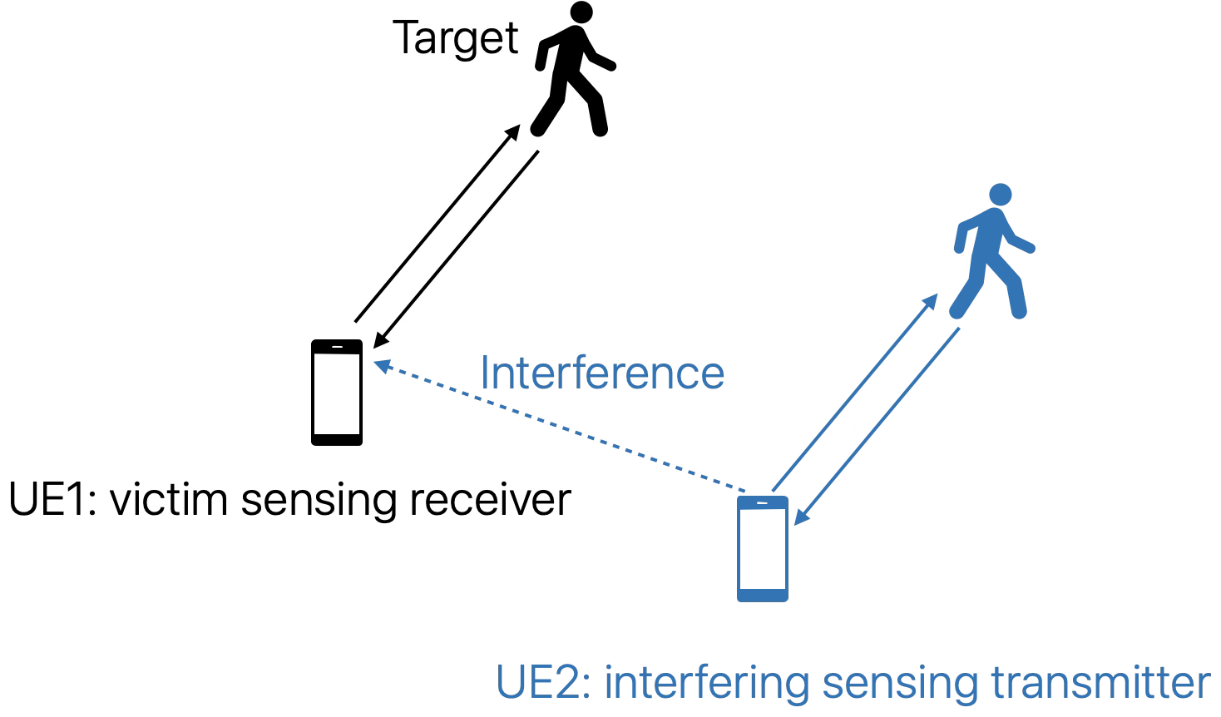
- UE1 and UE2 perform monostatic sensing on the same resource

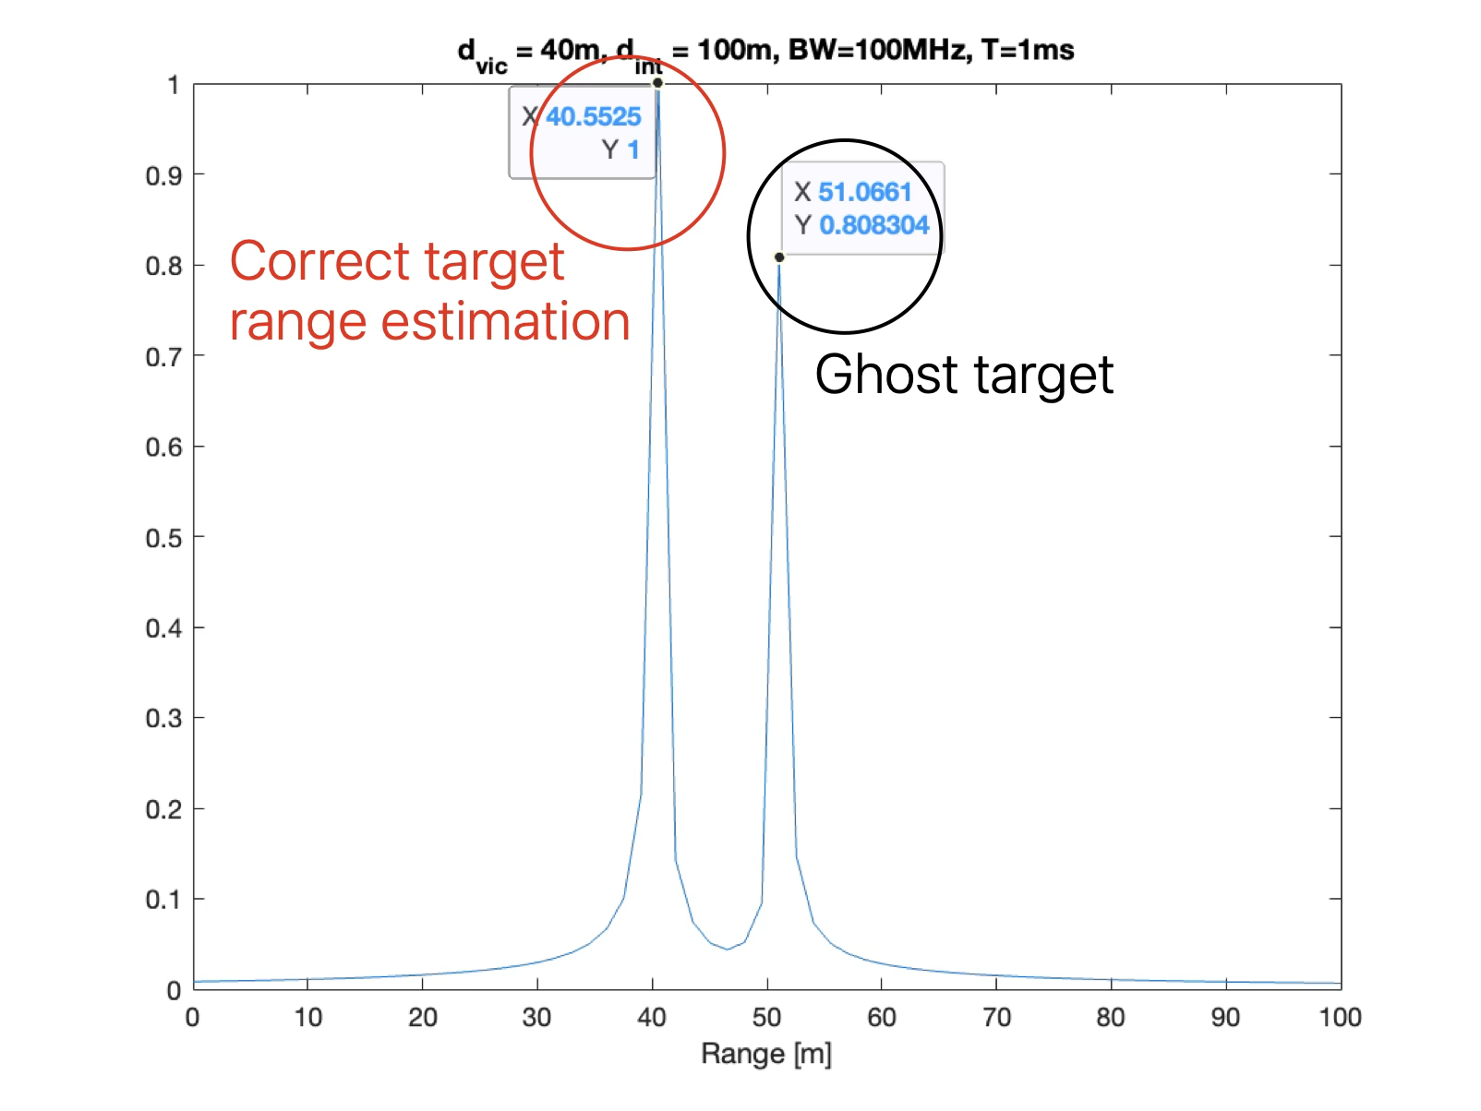
- Range profile when the two FMCW transmissions have the same frequency sweeping slope

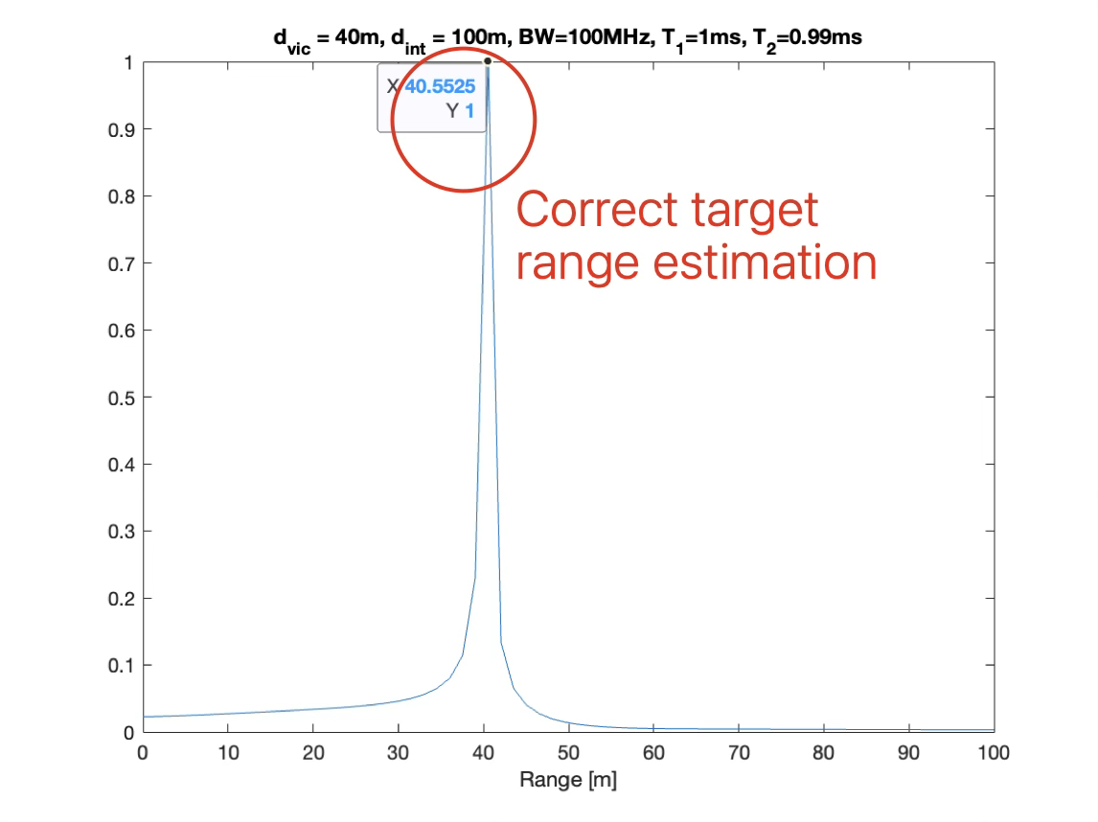
- Range profile when the two FMCW transmissions have different frequency sweeping slopes
Figure 2: mutual interference mitigation for FMCW-based sensing

Even with OFDM-based sensing, when the number of sensing transmissions exceeds the number of orthogonal sensing resources, non-orthogonal access to a common set of sensing resources is required. In this case, how to efficiently eliminate or reduce the mutual interference among multiple sensing transmissions should be studied.

Proposal 14: For Sensing Multiple Access and Interference Management
- Support basic orthogonal multiple access methods in OFDM-based sensing.
- Support the use of a transmission gap for UE based sensing
  - For transmission gap-based approach, study sensing multiple access when multiple sensing transmissions share the same gap
- Study the interaction of communications/sensing signals as well as sensing/sensing signals.

3.4 Sensing Measurements and Feedback:
In the R20 5G-A ISAC study, 4 levels of sensing measurements were recommended to RAN3 for consideration:
- Level A: Raw data per Tx antenna port per OFDM symbol per RX antenna port per TRP for a given time stamp
- Level B: Amplitude and phase profile of delay, and/or Doppler, and/or angle per TRP for a given time stamp by using window(s) of the consecutive samples in at least one profile of delay, and/or Doppler and/or angle domain
- Level C: per detected path/point measurements per Tx antenna port per TRP which may be reflected/scattered from scattering point(s).
- Level D: Object/target level measurement per gNB.
In RAN1 #124-bis, the following agreements were made [6]:
Agreement:
- On measurement for ISAC, study at least the following aspects.
  - Measurement definitions/levels for TRP-side measurement, taking the measurement Levels studied in NR ISAC as starting point
  - Measurement definitions/levels for UE-side measurement
  - Impacts of non-ideal factors on measurement
  - Other aspects are not precluded
  - Note: this discussion may or may not mean there is specification impact

Agreement:
- On measurement report for ISAC, study at least the following aspects and applicable scenarios (e.g., sensing modes, targets, etc.) from RAN1 perspective.
  - Measurement reporting mechanism from UE
    - Option 1A: The UE measurements and/or assistance information if needed from UE can be directly sent to aNB
    - Option 1B: The UE measurements and/or assistance information if needed from UE can be sent to SF
  - Measurement reporting mechanism from aNB
    - Option 2A: The aNB measurements and/or assistance information if needed from aNB can be directly sent to UE
    - Option 2B: The aNB measurements and/or assistance information if needed from aNB can be sent to SF
  - The study may require cross-WG coordination.
  - Note: combination of multiple options is not precluded.
  - Note: measurements in each option may be different

Agreement:
- On measurement report for ISAC, study impacts from at least the following aspects from RAN1 perspective
  - Measurement reporting mechanism
    - E.g., Periodic, semi-persistent, aperiodic, event-triggered report as starting point
    - Reporting signaling e.g., L1, L2, higher layer, etc.
  - Other aspects are not precluded
  - The study may require cross-WG coordination.

3.4.1 Measurement Levels for 6G OTA reporting

In the 5G-A study, the following agreement was made:
Agreement:
The following Text Proposal to Conclusion section in TR 38.765 is endorsed.
The study in physical layer has identified a number of Levels/Options for measurement report as described in Clause 5. Different Levels/Options for measurement report are associated with different payload overhead, assistance information and other higher layer aspects.

In addition, agreements were made on assumptions on the parameters can be used to estimate payload size of different Levels/Options of measurements for NR ISAC for calculation purpose.

We use the same parameters to estimate the payload for the different measurement levels in the table below:

Table 1: Payload Summary Across Levels
Level | Min Payload | Max Payload | OTA Feasibility
A | 161 MB | 7.2 GB | Infeasible
B1, B4 (per-port) | 14.2 MB | 3.2 GB | Infeasible
B2, B3 (Nangle=32) | 7.1 MB | 1.6 GB | Infeasible
B2, B3 (Nangle=360) | 79.6 MB | 17.9 GB | Infeasible
C (all options) | 900 B | 7.2 KB | Feasible
D (all options) | 210 B | 640 B | Feasible

Observation 9: There is large gap between the minimum Level B payload (7.1 MB) and the maximum Level C payload (7.2 KB). For OTA reporting, Level C/D is the only practical operating region. Level A/B payloads are feasible only over high-capacity backhaul links.

3.4.2 Non-Ideal Factors
The following non-ideal factors impact measurement definitions and feasible levels:

Self-interference (monostatic): In monostatic sensing, TX leakage power can exceed target echo power by up to 100 dB. Self-interference must be cancelled locally at the sensing node before any useful measurement can be reported. Residual SI may appear as artifacts in Level A/B reports; at Level C and above, SI is removed during local CFAR detection before reporting. This implies that for monostatic sensing, Level C is the practical minimum for inter-node measurement reports.

Inter-node timing offset (bistatic): Bistatic and cooperative sensing require TX–RX synchronization. Timing offset biases range estimates, frequency offset biases velocity/Doppler estimates, and phase offset prevents coherent combining across nodes. At Level A/B, these offsets corrupt the raw waveform and require full calibration before processing. At Level C/D, provided offsets are within the sensing node's operating tolerance, the sensing node absorbs them during local processing. Residual timing and frequency errors appear as biases on measurements, which can be corrected at the processing center if a reference is available. At Level A/B, the processing center must calibrate all offsets before any processing can begin.

Grating lobes (directional UE): Multi-port UE with limited aperture may experience angle ambiguity from grating lobes. This relates to the agreed note that "ambiguity issue will be further discussed." For affected configurations, reporting a candidate angle list rather than a single angle estimate may be needed.

Observation 10: Non ideal factors such as self-interference and internode timing, frequency and phase offsets limit the measurement levels to C and D. Non ideal factors such as grating lobes may require reporting of a candidate angle list rather than a single angle.

Proposal 15: Level C/D should be the baseline measurement level for OTA reporting paths and for inter-node links subject to timing, frequency, or phase offsets. Level A/B is primarily applicable to high capacity backhaul links with adequate synchronization.

3.4.3 Reporting Mechanisms
Based on the #124bis agreement to study measurement reporting mechanisms with periodic, semi-persistent, aperiodic, and event-triggered reporting as a starting point, we observe the following applicability to ISAC:

Proposal 16: RAN1 should study the following measurement reporting mechanisms for ISAC:
Reporting Type | Description
periodic | Basic sensing resolution with large ReportGranularityFactor ("configurable reporting granularity and payload size") and limited size. Suited for continuous monitoring at a configured interval
semi-persistent | Activated/deactivated via MAC-CE or LPP-like protocol. Applicable when sensing reporting is needed over a bounded duration.
aperiodic | Detailed sensing information in high resolution, initiated based on a sensing event detected during periodic monitoring. Successive aperiodic requests may progressively increase reporting granularity.
event-triggered | Report generated when a sensing-related condition is detected (e.g., LOS/NLOS change, sensing quality variation).
The reporting mechanisms and parameters such as reporting granularity, accuracy, reporting overhead, and latency can be set semi-statically or dynamically based on the sensing requirements or on requests from the SRX or the sensing processing function.

3.5 Bandwidth Aggregation
In Rel-18 Positioning, phase coherent bandwidth aggregation was standardized to improve the accuracy of positioning. For sensing, the range resolution is fundamentally inversely proportional to the total signal bandwidth. Similar methods to the Rel-18 positioning solution should be discussed.

Proposal 17: Study bandwidth aggregation to enable increase in bandwidth for improved range resolution.

3.6 Power Control
In RAN1 #124-bis, the following proposal was discussed in the FL summary [7]:
- On power control for ISAC, study at least the following aspects, considering both sensing performance and impacts to communication.
  - P0/alpha
  - Pathloss reference
  - CL PC
  - PHR
  - DL PC
  - Impact to phase continuity within CPI
  - Other aspects are not precluded

NR power control is designed to compensate one-way pathloss between a transmitter and a receiver (e.g., UE to gNB for uplink). For sensing transmissions, the propagation geometry is fundamentally different:
- Mono-static sensing: The signal travels from STx to target and back to SRx (co-located with STx). The relevant loss metric is the two-way coupling loss, which includes STx→target and target→SRx path losses plus target reflection characteristics (RCS).
- Bi-static sensing: STx and SRx are at different locations. The signal travels STx→target→SRx. The coupling loss depends on both path segments and the target RCS. A reference signal from SRx can only estimate the SRx→STx pathloss, which is less than or equal to the full two-leg coupling loss.
- Cooperative sensing: Multiple SRx nodes participate. Each SRx experiences different coupling loss to the target, requiring multiple power reference points.
These differences imply that:
- A single pathloss reference RS (as used in NR communication) cannot adequately characterize the sensing propagation condition.
- Power control parameters (P0, alpha) should be indexed by the sensing context, including the sensing mode, requirement class, and beam/target configuration.
- Dynamic power adaptation based on sensing detection quality is needed, since the target channel is not reciprocal and cannot be predicted from the communication channel alone.
- Power headroom reporting must account for sensing power demands and sensing modes to prevent overscheduling by the network and mode specific power limitations.
Observation 11: Direct application of communication-oriented power control is not sufficient for sensing transmissions. The two-way (or multi-leg) nature of sensing propagation, the dependence on target RCS, and the variety of sensing modes require a sensing-specific power control framework.

Proposal 18: Study the power control framework needed to support sensing and communications, including
- A single pathloss reference RS (as used in NR communication) cannot adequately characterize the sensing propagation condition.
- Power control parameters (P0, alpha) should be indexed by the sensing context, including the sensing mode, requirement class, and beam/target configuration.
- Dynamic power adaptation based on sensing detection quality is needed, since the target channel is not reciprocal and cannot be predicted from the communication channel alone.
- Power headroom reporting must account for sensing power demands and sensing modes to prevent overscheduling by the network and mode specific power limitations

3.6.1 Path Loss Reference
In communication, the network configures a pathloss reference RS (pathlossReferenceRS-ID) to a UE, and the UE determines its transmit power by measuring the configured reference signal and deriving the pathloss accordingly. Applying this framework directly to sensing is not straightforward, since the transmitting node of the reference signal used for pathloss or coupling loss estimation may differ depending on the sensing mode. To estimate the path loss, RAN1 should study the need for a sensing reference entity that may be configured with an associated sensing RS and sensing power control parameters for sensing power reference purposes. This may depend on the sensing mode and be different for mono-static, bi-static and multi-target/multi-beam sensing.

Proposal 19: To estimate the path loss, RAN1 should study the need for a sensing reference entity that may be configured with an associated sensing RS and sensing power control parameters for sensing power reference purposes. The reference entity, RS and parameters may depend on the sensing mode and be different for mono-static, bi-static, multi-target/multi-beam and cooperative sensing.

3.6.2 Sensing Context and Power Control
NR power control parameters (P0, alpha, closed-loop index) are configured per BWP and per PUSCH/PUCCH/SRS. For sensing, the power control requirements vary significantly across sensing contexts made up of:
- Sensing mode: mono-static, bi-static (UE-TRP, UE-UE), cooperative
- Sensing requirement class: range/coverage objective, resolution class
- Relationship of sensing and communication: sensing-only, joint sensing/communication, TDM
- Beam group or target configuration: single-beam, multi-beam sweep, multi-target
RAN1 should study the configuration of multiple sensing power control parameter sets including the power control mechanism indexed by the sensing context to enable the right sensing TPC to be selected at the right time.
Proposal 20: RAN1 should study the configuration of one or more sensing power control parameter sets including the power control mechanism, each associated with a sensing context and how the UE determines which set to apply. The possibility of a change in the parameter sets when the sensing context changes (e.g., mode transition, beam group switch) should also be explored.

3.6.3 Dynamic Sensing Power adaptation
In NR, uplink power control is primarily designed for communication purposes and relies on network-centric closed-loop feedback mechanisms (e.g., HARQ, RAR, TPC commands) to ensure reliable reception at the gNB. Existing NR open-loop uplink power control mechanisms based on pathloss estimation are not sufficient to guarantee reliable sensing performance under such highly dynamic sensing channel conditions. Also unlike in uplink power ramping methods for the random-access procedure in communications, where an uplink power increase is triggered by the absence of a Random-Access Response (RAR), there is currently no feedback or decision mechanism for determining whether the sensing transmission power is sufficient for successful sensing detection. Without a sensing-specific dynamic power adaptation mechanism, the sensing UE may experience frequent sensing failures, sensing blind spots, excessive sensing latency, or unnecessarily high transmit power, leading to unpredictable interference to other users and networks. If dynamic power adaptation is insufficient to meet the sensing requirement (e.g., target beyond single-node coverage), the UE may request a sensing mode transition (e.g., mono-static to cooperative), changing the applicable power control parameter set accordingly.

Proposal 21: RAN1 should study how to enable power ramping mechanisms to dynamically adapt the sensing transmit power based on sensing detection quality and network-assisted guardrails including the UE's behavior when power adaptation alone is insufficient.

3.6.4 Power Headroom Reporting

Existing NR PHR is designed for communication-only operation. When sensing is active:
- TDM sensing increases the apparent power headroom. In slots without sensing, the UE appears to have full headroom, but the average power budget is reduced by sensing duty cycle.
- Simultaneous communications and sensing may invisibly consume power as the network cannot see that sensing is consuming part of the UE’s power capacity.
- The transmit power allowed may be dependent on the sensing mode. As an example, there may be different maximum power allowed for mono-static, bi-static sensing or cooperative sensing.
Without sensing-aware PHR, the gNB may over-schedule uplink communication, leading to power saturation and performance degradation of both sensing and communication

Proposal 22: RAN1 should study sensing aware PHR estimation and reporting. The study should consider scenarios with and without communications and should account for the sensing mode.

23.7 Beam Management
For beam management in sensing, RAN1 should study the effect of sensing on Communications/Sensing Precoding/beamforming.

3.7.1 Communications/Sensing Precoding/beamforming
In ISAC systems, when multiple transmit antennas together with precoding are employed for data communication, the joint sensing task becomes inherently challenging as the communication signal may not be spatially directed toward the sensing target of interest.
An example is illustrated in Figure 3. Figure 3(a) shows a scenario where a UE performs joint UL transmission and UE monostatic sensing (i.e., the same Tx waveform for both communication). Also, assume codebook-based transmission is applied to UL with 4Tx-4Rx and 1-layer transmission. Figure 3(b) shows the angle estimation performance when five 4-by-1 precoders from the specified NR codebook are used respectively. As shown, the angle estimation performance largely depends on the applied precoder, where different target angles prefer different precoders. For instance, for a target angle within [20,35] degrees, precoder 2 and precoder 3 cannot be applied, while precoder 1 or precoder 5 should be selected.

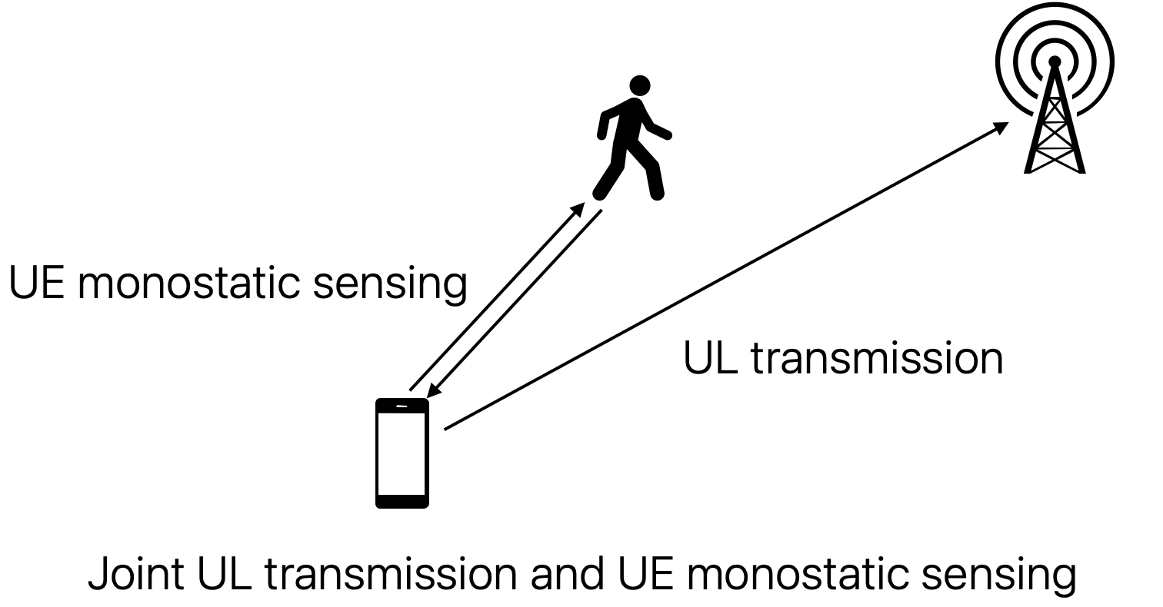
(a). joint UL transmission and UE monostatic sensing

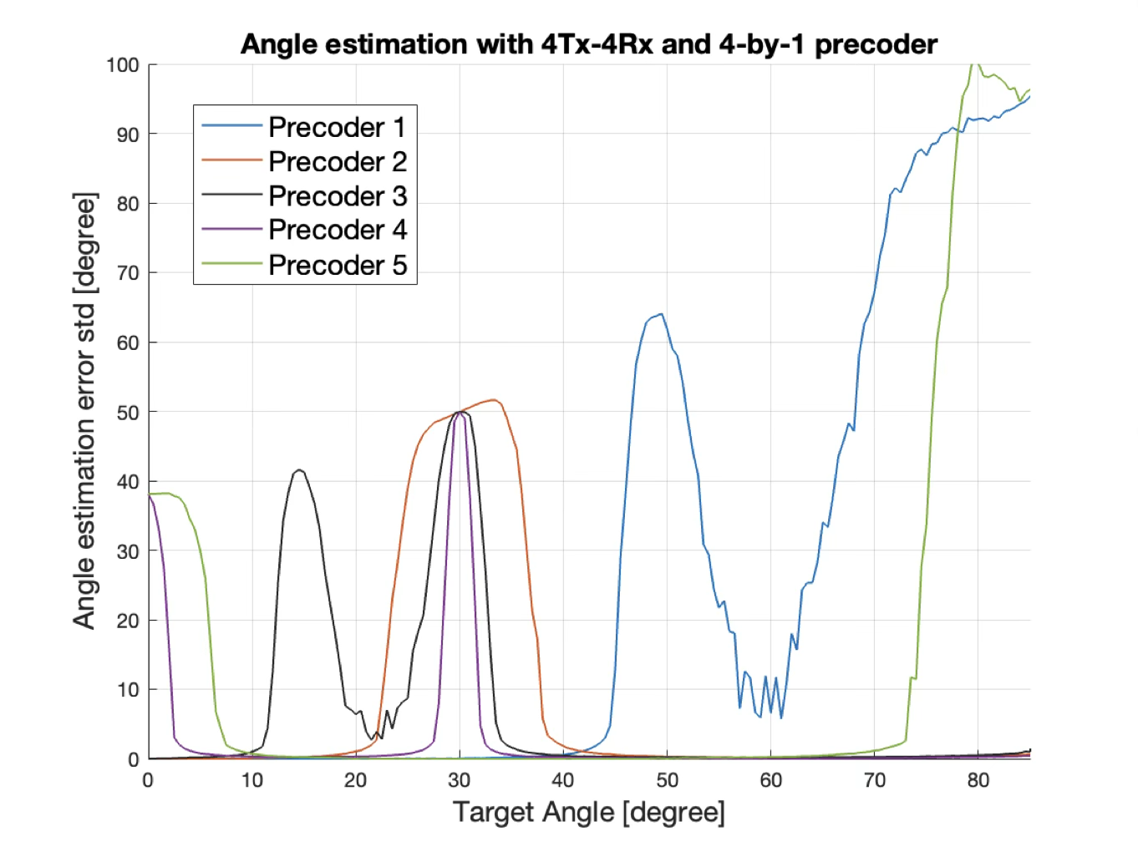
(b). angle estimation performance with different precoders
Figure 3: Impacts of UL precoder selection for joint communication and sensing

Observation 12: for joint communication and sensing, the UL precoder selected by NW for communication may be unfavorable to sensing.

To address this, it may be necessary to modify the precoder or beamformer design to simultaneously accommodate both communication and sensing requirements, or alternatively, to allocate separate time-domain resources for sensing-oriented beam configurations.

Proposal 23: Consider enhanced UL multi-antenna transmission for ISAC. Study the precoding/beamforming mechanisms needed to accommodate both communications and sensing requirements.

3 Sensing Aided Communications

In RAN1 #124-bis, the following proposal was made by the FL
- For the purpose of study, companies are encouraged to bring up usage scenarios for sensing assisted communication. For each usage scenario, please input at least the following aspects
  - Which feature of communication is to be assisted?
  - Which sensing measurements are useful for the assistance?
  - How the sensing measurements are used to assist the feature of communication?
  - Up to company to report the additional impact to physical layer designs, if necessary
- Note: whether/how to evaluate a usage scenario is to be discussed in 10.8.1

Proposal 24: RAN1 should study Sensing Assistance for Beam Management
Feature Assisted | Beam Management procedures including initial beam acquisition, beam tracking, and beam failure recovery (BFR).  Sensing enables both reactive (respond to current blockage) and predictive (anticipate future blockage) beam management.
Sensing Measurements | LOS/NLOS channel identification: determines propagation condition between UE and TRP  Blockage detection: identifies blockers in the propagation path, including range and velocity for prediction of future blockage  Applicable sensing modes: UE mono-static, TRP mono-static, TRP-UE bi-static, UE-TRP bi-static
How the sensing measurements are used to assist communications | In reactive mode, sensing detects current blockage and enables earlier beam failure detection than legacy L1-RSRP mechanisms. The candidate beam search space is narrowed using sensing-derived blockage information.  In predictive mode, sensing tracks blocker trajectory to anticipate blockage before it impacts the communication link, enabling proactive beam reconfiguration.
Additional PHY Layer Impact | Sensing RS configuration alongside legacy BFR reference signals  Sensing-based beam failure trigger in parallel with legacy L1-RSRP-based BFR  Beam set framework for dynamic beam configuration selection based on sensing  UE-triggered BM reporting carrying sensing-derived information
Evaluation | SLS with dynamic blockers.  Baseline: legacy BFR.  KPIs: throughput during blockage, beam alignment latency, BFR success rate

Proposal 25: RAN1 should study Event-Based Communication Assistance
Feature Assisted | Sensing is conditionally triggered/stopped/switched based on observable conditions. Assisted features: beam tracking, blockage handling, power management
Sensing Measurements | Trigger conditions from communication and sensing observables:  Channel/interference (CQI/MCS, RSRP/SINR, Doppler)  Propagation (LOS/NLOS state change)
How the sensing measurements are used to assist communications | Sensing starts when event occurs, results drive a communication adaptation and stops when the condition clears.  We get same benefit as always-on sensing with reduced overhead and power consumption.
Additional PHY Layer Impact | Trigger condition configuration and thresholds  Start/Continue/Stop/Switch signaling (self and inter-node)  Per-trigger sensing mode ↔ communications adaptation association
Evaluation | SLS sweeping trigger thresholds.  Baseline: always-on or no sensing.  KPI: overhead, performance, power

Conclusion
In this contribution, we provided our views on integration of sensing with communications. We have the following observations, proposals and conclusions:

Observations:

Observation 1: No single existing NR RS satisfies the sensing requirements. Every RS type has limitations.

Observation 2: For DL,
- PRS has the best sensing properties (unprecoded, staggered, configurable comb) but is not deployed.
- TRS is the best deployed DL RS: unprecoded, cell/BWP-level, fixed comb-4, periodic, designed for time/frequency tracking.
- TRS is a subtype of CSI-RS but with distinctly more favorable sensing properties.

Observation 3: For UL,
- SRS for Positioning has the best sensing properties (staggered, comb-2/4/8) but is not deployed.
- SRS (Rel-17+) is the best deployed UL option with flexible symbol placement but lacks staggering.

Observation 4: SSB (PSS/SSS/PBCH):
- It is always-on with a narrow bandwidth.
- It is useful as coarse sensing signal in multi-resolution approaches.

Observation 5: TRS is the natural starting point for enhanced sensing RS due to its favourable deployed properties, but it lacks staggering, configurable density, dynamic adaptation, and phase continuity guarantees. An update to the configuration could address all these gaps while adding PRS-like capabilities.
NOTE: the updates will have to ensure that the primary communications requirements are preserved.

Observation 6: SRS (Rel-17+) is the natural starting point for enhanced UL sensing RS due to its favourable deployed properties, but it lacks staggering, flexible comb, sensing-aware power control, CPI duration configuration, and phase continuity guarantees. The updates address all these gaps while adding SRS-Pos-like capabilities.
NOTE: the updates will have to ensure that the primary communications requirements are preserved

Observation 7: Multi-resolution sensing (coarse SSB + fine wideband RS) offers lower computational complexity and power savings than single-RS approaches for comparable performance by applying RS reuse and RS enhancement.

Observation 8: There are existing QCL Types that can support sensing. However, Legacy NR has no QCL type indicating phase coherency across multiple RS resources. A new QCL-phaseCoherency type is needed for coherent combining of augmented RS groups, joint enhanced+dedicated RS, multi-resolution RS, and cross-CC/BWP sensing.

Observation 9: There is large gap between the minimum Level B payload (7.1 MB) and the maximum Level C payload (7.2 KB). For OTA reporting, Level C/D is the only practical operating region. Level A/B payloads are feasible only over high-capacity backhaul links.

Observation 10: Non ideal factors such as self-interference and internode timing, frequency and phase offsets limit the measurement levels to C and D. Non ideal factors such as grating lobes may require reporting of a candidate angle list rather than a single angle.

Observation 11: Direct application of communication-oriented power control is not sufficient for sensing transmissions. The two-way (or multi-leg) nature of sensing propagation, the dependence on target RCS, and the variety of sensing modes require a sensing-specific power control framework.

Observation 12: for joint communication and sensing, the UL precoder selected by NW for communication may be unfavourable to sensing.

Proposals:

Proposal 1: For ISAC in the 6G first release, use cases that involve the UE as a sensing transmitter and/or receiver should be supported in 6GR

Proposal 2: Allowance for all network nodes as sensing result/service consumers is essential i.e. UE-mono-static, TRP-UE bi-static, UE-TRP bi-static, UE-UE bi-static
- UE-centric modes in which the UE may request, process, and most importantly, consume sensing measurements while the NW is responsible for resource allocation should be supported in 6GR

Proposal 3: PHY functions and procedures and communications integration for key Use Cases such as Object Detection and Tracking of objects and the environment surrounding the UE/TRP and Sensing Aided Communications should be studied.

Proposal 4: Privacy for sensing entity, sensing data, and associated PHY functions and procedures should be central to the design.

Proposal 5: The following RS ranking for sensing suitability is proposed as baseline for further study:
- DL: PRS > TRS > CSI-RS > DMRS > SSB > PTRS
- UL: SRS for Positioning > SRS (Rel-17+) > DMRS>PTRS
where '>' indicates higher sensing suitability considering sensing performance, resource overhead, deployment status, and flexibility. PTRS is ranked last for DL due to its role being limited to phase/Doppler augmentation of other RS.

Proposal 6: Study RS augmentation approaches where additional RS resources are configured and grouped with a base communication RS to form a staggered sensing pattern, including configurable ports, power levels, and overhead per use case.

Proposal 7: Study multi-use RS(s) configuration that can serve communication, positioning, and sensing simultaneously, and RS configuration for multi-TRP and/or cooperative sensing.

Proposal 8: Study multi-resolution sensing approaches that jointly utilize reused RS (e.g., SSB for coarse estimation) and enhanced RS (e.g., wideband parameterized RS for fine estimation), including two-step processing and object/target association between coarse and fine RS observing the same target.

Proposal 9: Study the use of a dedicated sensing RS with a parameterized framework supporting configurable staggering, spacing, ports, and repetitions as a unified design for DL and UL. Candidate structures (e.g., CDM-group-based) should be evaluated for the case of no active communications, extreme sensing requirements, and/or insufficient RS density of the basic or enhanced sensing RS.

Proposal 10: Study QCL aspects for sensing, including:
- Applicability of existing NR QCL types (TypeA, TypeC, TypeD) for sensing
- A new QCL type (QCL-phaseCoherency) indicating phase coherency across multiple RS resources, with an associated expiry time
- QCL across CCs/BWPs for improved sensing resolution

Proposal 11a: Study the sensing RS design aspects including RS patterns, parameters, configuration, and triggering mechanisms, considering dependence on sensing mode and target properties.

Proposal 11b: Study the interaction between sensing RS and communications data including communications signal reuse, adaptation to deployment needs, and sensing RS overhead.

Proposal 11c: Study the sensing RS design over the Coherent Processing Interval (CPI) including power consistency and phase continuity requirements across the multiple symbols transmitted within the CPI.

Proposal 12: Study the following RE pattern types for sensing RS:
- Comb: all OFDM symbols use the same frequency offset
- Ramped (linear shift): frequency offset increases linearly per symbol
- Staggered: frequency offset varies across symbols to maximize frequency domain coverage

Proposal 13: The RE pattern type study should use the range/positioning accuracy and the velocity accuracy as metrics, subject to probability of missed detection and probability of false alarm limits. The effect of the patterns on the ambiguous range, sidelobe peaks, and accuracy and the effect of RS density on the performance should also be studied.

Proposal 14: For Sensing Multiple Access and Interference Management
- Support basic orthogonal multiple access methods in OFDM-based sensing.
- Support the use of a transmission gap for UE based sensing
  - For transmission gap-based approach, study sensing multiple access when multiple sensing transmissions share the same gap
- Study the interaction of communications/sensing signals as well as sensing/sensing signals.

Proposal 15: Level C/D should be the baseline measurement level for OTA reporting paths and for inter-node links subject to timing, frequency, or phase offsets. Level A/B is primarily applicable to high capacity backhaul links with adequate synchronization.

Proposal 16: RAN1 should study the following measurement reporting mechanisms for ISAC:
Reporting Type | Description
periodic | Basic sensing resolution with large ReportGranularityFactor ("configurable reporting granularity and payload size") and limited size. Suited for continuous monitoring at a configured interval
semi-persistent | Activated/deactivated via MAC-CE or LPP-like protocol. Applicable when sensing reporting is needed over a bounded duration.
aperiodic | Detailed sensing information in high resolution, initiated based on a sensing event detected during periodic monitoring. Successive aperiodic requests may progressively increase reporting granularity.
event-triggered | Report generated when a sensing-related condition is detected (e.g., LOS/NLOS change, sensing quality variation).
The reporting mechanisms and parameters such as reporting granularity, accuracy, reporting overhead, and latency can be set semi-statically or dynamically based on the sensing requirements or on requests from the SRX or the sensing processing function.

Proposal 17: Study bandwidth aggregation to enable increase in bandwidth for improved range resolution.

Proposal 18: Study the power control framework needed to support sensing and communications, including
- A single pathloss reference RS (as used in NR communication) cannot adequately characterize the sensing propagation condition.
- Power control parameters (P0, alpha) should be indexed by the sensing context, including the sensing mode, requirement class, and beam/target configuration.
- Dynamic power adaptation based on sensing detection quality is needed, since the target channel is not reciprocal and cannot be predicted from the communication channel alone.
- Power headroom reporting must account for sensing power demands and sensing modes to prevent overscheduling by the network and mode specific power limitations

Proposal 19: To estimate the path loss, RAN1 should study the need for a sensing reference entity that may be configured with an associated sensing RS and sensing power control parameters for sensing power reference purposes. The reference entity, RS and parameters may depend on the sensing mode and be different for mono-static, bi-static, multi-target/multi-beam and cooperative sensing.

Proposal 20: RAN1 should study the configuration of one or more sensing power control parameter sets including the power control mechanism, each associated with a sensing context and how the UE determines which set to apply. The possibility of a change in the parameter sets when the sensing context changes (e.g., mode transition, beam group switch) should also be explored.

Proposal 21: RAN1 should study how to enable power ramping mechanisms to dynamically adapt the sensing transmit power based on sensing detection quality and network-assisted guardrails including the UE's behavior when power adaptation alone is insufficient.

Proposal 22: RAN1 should study sensing aware PHR estimation and reporting. The study should consider scenarios with and without communications and should account for the sensing mode.

Proposal 23: Consider enhanced UL multi-antenna transmission for ISAC. Study the precoding/beamforming mechanisms needed to accommodate both communications and sensing requirements.

Proposal 24: RAN1 should study Sensing Assistance for Beam Management
Feature Assisted | Beam Management procedures including initial beam acquisition, beam tracking, and beam failure recovery (BFR).  Sensing enables both reactive (respond to current blockage) and predictive (anticipate future blockage) beam management.
Sensing Measurements | LOS/NLOS channel identification: determines propagation condition between UE and TRP  Blockage detection: identifies blockers in the propagation path, including range and velocity for prediction of future blockage  Applicable sensing modes: UE mono-static, TRP mono-static, TRP-UE bi-static, UE-TRP bi-static
How the sensing measurements are used to assist communications | In reactive mode, sensing detects current blockage and enables earlier beam failure detection than legacy L1-RSRP mechanisms. The candidate beam search space is narrowed using sensing-derived blockage information.  In predictive mode, sensing tracks blocker trajectory to anticipate blockage before it impacts the communication link, enabling proactive beam reconfiguration.
Additional PHY Layer Impact | Sensing RS configuration alongside legacy BFR reference signals  Sensing-based beam failure trigger in parallel with legacy L1-RSRP-based BFR  Beam set framework for dynamic beam configuration selection based on sensing  UE-triggered BM reporting carrying sensing-derived information
Evaluation | SLS with dynamic blockers.  Baseline: legacy BFR.  KPIs: throughput during blockage, beam alignment latency, BFR success rate

Proposal 25: RAN1 should study Event-Based Communication Assistance
Feature Assisted | Sensing is conditionally triggered/stopped/switched based on observable conditions. Assisted features: beam tracking, blockage handling, power management
Sensing Measurements | Trigger conditions from communication and sensing observables:  Channel/interference (CQI/MCS, RSRP/SINR, Doppler)  Propagation (LOS/NLOS state change)
How the sensing measurements are used to assist communications | Sensing starts when event occurs, results drive a communication adaptation and stops when the condition clears.  We get same benefit as always-on sensing with reduced overhead and power consumption.
Additional PHY Layer Impact | Trigger condition configuration and thresholds  Start/Continue/Stop/Switch signaling (self and inter-node)  Per-trigger sensing mode ↔ comm adaptation association
Evaluation | SLS sweeping trigger thresholds.  Baseline: always-on or no sensing.  KPI: overhead, performance, power

References
- RP-253246, Revised SID: Study on Integrated Sensing And Communication (ISAC) for NR
- TR 38.914, Study on 6G Scenarios and Requirements (Release 20) .
- TR 38.765, Study on Integrated Sensing And Communication (ISAC) for NR (Release 20)
- TR 22.837, Study on Integrated Sensing and Communication
- R2-2601824, On UE-centric sensing, Apple, MediaTek Inc., ASUSTeK, OPPO, Google, vivo, Lenovo
- Draft Report of 3GPP TSG RAN WG1 #124-bis, April 2026
- R1-2602591 Summary #3 on integration with communication for ISAC, Xiaomi, April 2026

